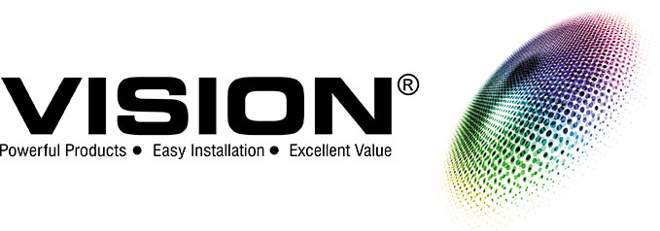
Vision dSCR Multi-Switch
Installation Guide
EV5-D2S, D4S, D6S, D8S

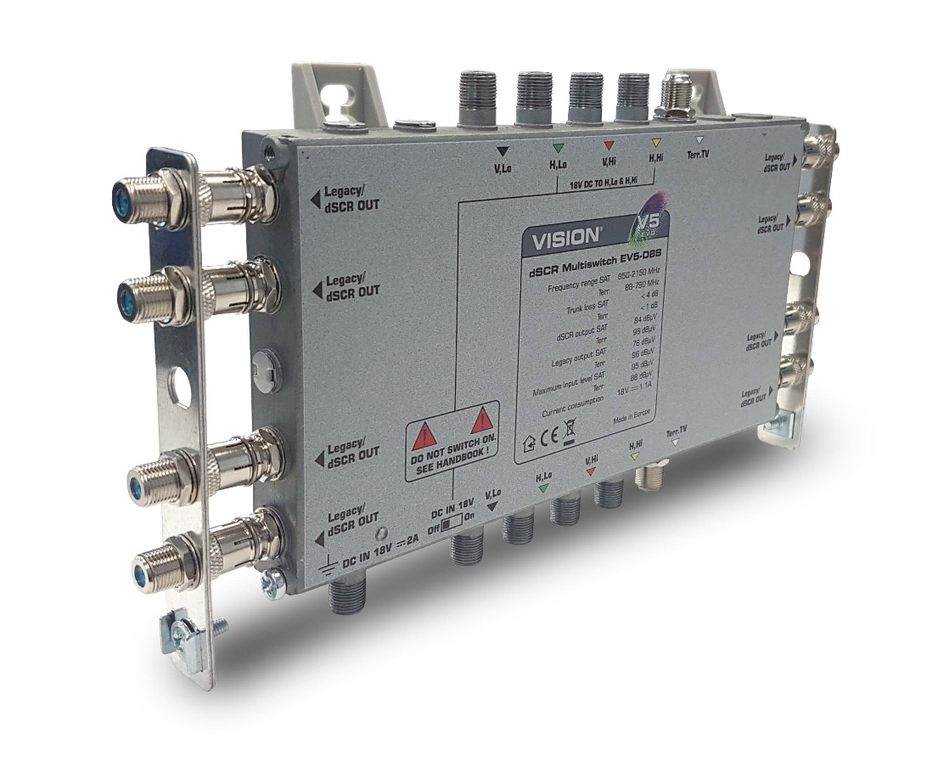
Vision dSCR Multi-Switch Guide
EV5-D2S, D4S, D6S, D8S

INTRODUCTION

The Vision range of dSCR products provide a totally reliable and cost-effective way to add Sky Q functionality (and other products such as more modern Freesat receivers) using the dSCR protocol to existing systems, or to create a new IRS installation.

Built in an aerospace quality production facility using a Nitrogen atmosphere for maximum operating life, the VISION dSCR range will connect directly to all VISION EV5 switch systems. They can also be used with other manufacturers switches with appropriate care.

EV5 dSCR-S models can be locally powered in addition to a line powering facility, permitting the powering from a subscriber location if this is more convenient. (see POWERING section of this handbook).

Care has been taken to ensure the UHF TV (terrestrial signal) gain are similar level to the existing Vision EVO V5 range of IRS products, making upgrading an existing Vision EV5 system very simple and extremely fast.

To further speed installation, the connector pitch and sequence exactly match existing Vision EV5 switches and taps, making physical connection very rapid indeed. The dSCR switches also feature fully automatic level control, negating the need for any gain or level adjustments in most installations.

It is also possible to build a dSCR only cascaded multi-switch system for several dwellings or apartments from a standard 5-core trunk cable.

Vision Products (Europe) Ltd offer a free planning service for installers and can advise on any aspect of installation of IRS and other TV signal systems, including fibre optic, MATV, CATV etc.

IMPORTANT WARNINGS
- The EV5-dSCR multi-switches are intended only for indoor installation or installation in a suitable weatherproof outdoor cabinet. These multi-switches must not come into contact with moisture or be installed in areas of high humidity or heat.

- Always mount the multi-switch securely to a wall or bulkhead panel so it cannot hang or swing on its coaxial cables as this may strain the internal circuit board and components.

- Always connect all of the coaxial cables to the multi-switch before connecting the power. These units are not designed to be “hot-swapped” or connected to a live system.

- Momentary short-circuit of any cables may be enough to damage the sensitive electronics within the multi-switch or the connected system.

- Always allow plenty of ventilation around the multi-switch and do not allow it to be covered with materials such as loft insulation.
- We recommend at least 5cm of airspace around the multi-switch. Digital products can get hot to the touch and require a flow of air to avoid overheating.

- Always earth-bond the output cables of the multi-switch before powering the system. Floating voltages can be created in an un-earthed system which may cause damage and can be dangerous.

- Vision EV5-dSCR multi-switches are designed only to work with normal Ku band (Sky) Quattro LNBs.

- The trunk lines, H: Lo and H: Hi, will pass DC at up to 2A in either direction. To avoid damage not covered by warranty DO NOT EXCEED THIS CURRENT.

- Do not operate the power slide switch unless you totally understand the power demands of the system and confirmed they are 2A or less. Damage caused by current overload is not covered by the manufacturer’s warranty.

POWERING

There are 3 ways to power “S” series of EV5-dSCR multi-switches.

- By a stand-alone 18V power supply (EV5-034) into the DC in socket of the dSCR multi-switch with the DC switch on the top of the multi-switch in the “OFF” position. Recommended.

- By a stand-alone 18V power supply (EV5-034) into the DC in socket of the dSCR multi-switch with the DC switch on the top of the multi-switch in the “ON” position. This allows the power supply to power a number of multi-switches and the LNB to build a cascaded system. Warning! Check the current consumption of all items on the system. They must not exceed the rating of the power supply or the DC 2A pass capability of the EV5-dSCR multi-switch.

- With the DC switch on the top of the multi-switch housing in the “ON” position, the EV5-dSCR multi-switch will draw current and power from the trunk line of the existing system. WARNING! DO NOT EXCEED THE CURRENT CAPABILITY OF THE POWER SUPPLY OR SYSTEM. SERIOUS DAMAGE CAN OCCUR IF OVERLOADED.

INSTALLATION

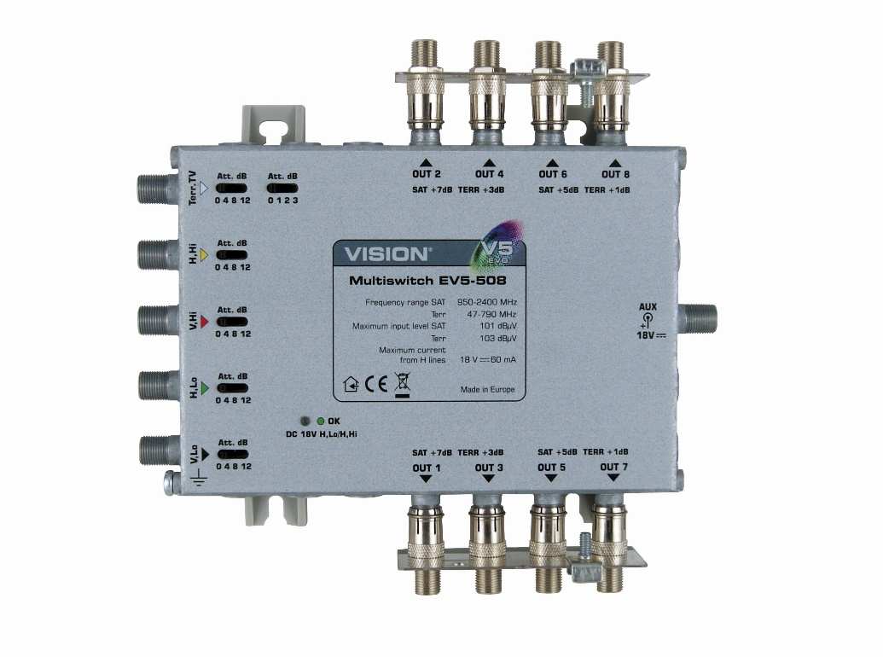
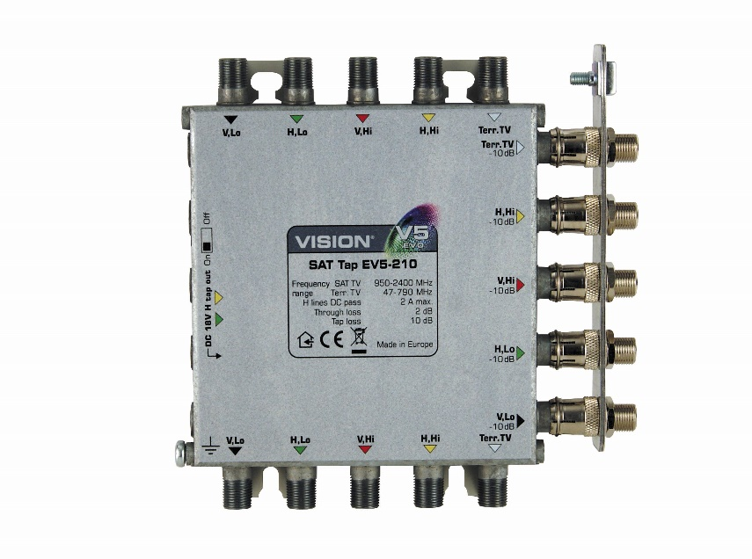

EV5-dSCR multi-switches are ideal for insertion between the tap and a multi-switch of a standard V5/EV5 IRS installation. Using the EV5-dSCR to upgrade a system in this way minimises disruption and ensures ongoing performance of the existing system.
Insert the EV5-dSCR between the tap and multi-switch of an existing system. With the DC switch in the off position, power the dSCR with its own power supply: -

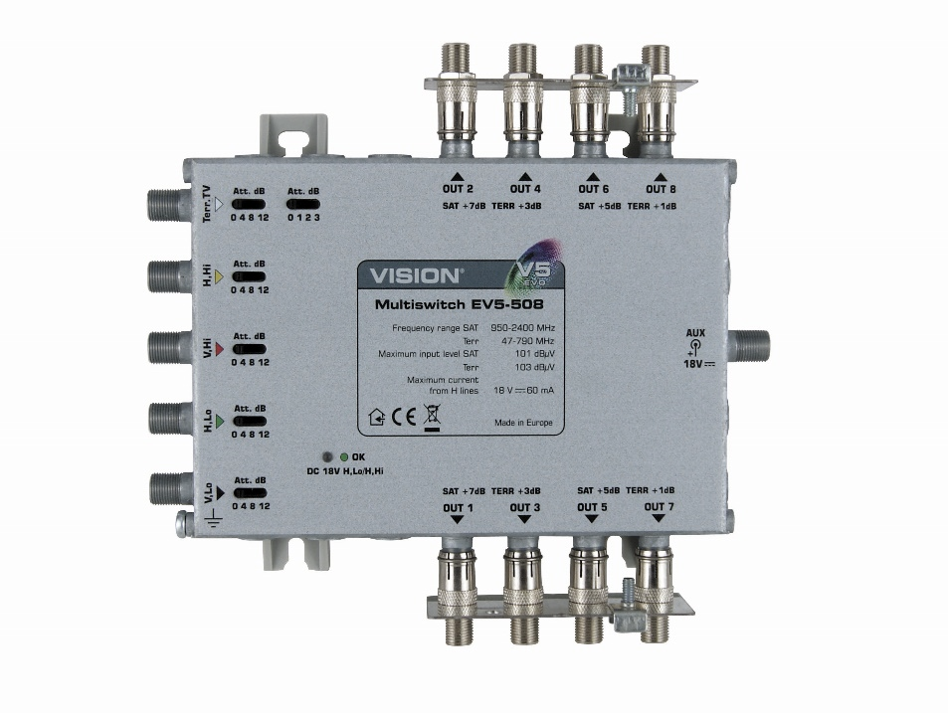
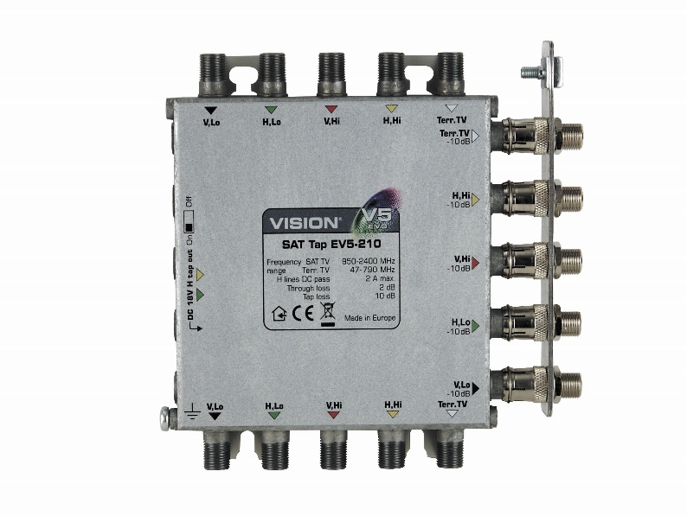
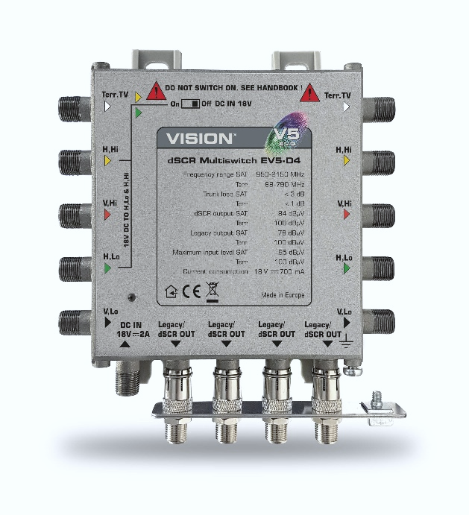

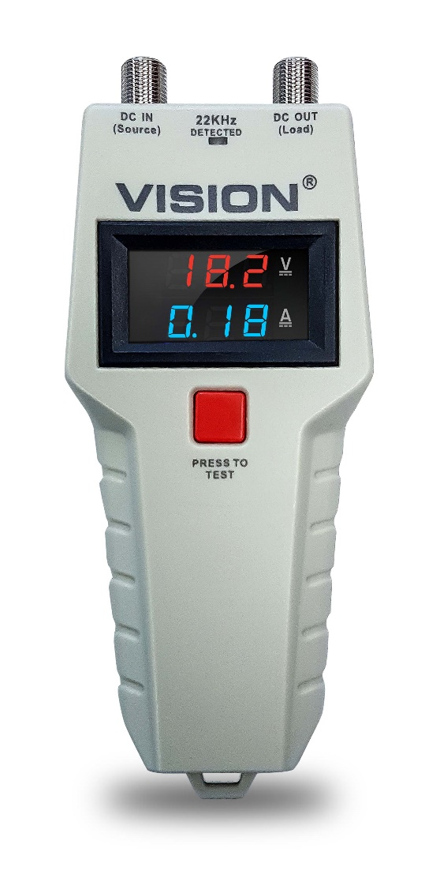
Always leave the DC switch in the OFF position when inserting EV5-dSCR into an existing multi-switch installation.

Power the EV5-dSCR at 18V using EV5-034 power supply connected to the auxiliary DC “IN” socket on the switch. Ensure the power supply is switched off before connection.

If you are unsure of the current being drawn from any part of the system, we recommend the use of the Vision V18-310 IRS power meter. This inexpensive meter displays both voltage and current in live systems. (see picture left).

WARNING! Adding EV5-dSCR may draw more current than the system is capable of delivering.

Once fitted and connected, turn on the power supply and then connect the receiver(s). The multi-switch will then begin the process of auto-detecting the type(s) of receiver connected. This process may need to be repeated if a different type of satellite receiver is connected to the system.

Please note: It may take several minutes for the receiver to download the EPG from the satellite provider.

©2020 Vision Products (Europe) Ltd.
24 Faraday Ct. Wellingborough. NN8 6XY
www.vision-products.co.uk
01933 677 220

